Headset icon  
<a href="https://www.flaticon.com/free-icons/headphone" title="headphone icons">Headphone icons created by lakonicon - Flaticon</a>  
  
Dancing Music  
<a href="https://www.flaticon.com/free-stickers/music" title="music stickers">Music stickers created by Stickers - Flaticon</a>  
  
Diamond  
<i class="fi fi-ss-diamond"></i>  
  
Fast shipping  
<i class="fi fi-ts-shipping-fast"></i>  
  
Speaker  
<a href="https://www.flaticon.com/free-icons/audio-system" title="audio system icons">Audio system icons created by Maan Icons - Flaticon</a>  
  
Fast Delivery  
<a href="https://www.flaticon.com/free-icons/fast-delivery" title="fast delivery icons">Fast delivery icons created by Darius Dan - Flaticon</a>  
  
Money back guarantee  
<a href="https://www.flaticon.com/free-icons/guarantee" title="guarantee icons">Guarantee icons created by nangicon - Flaticon</a>  
  
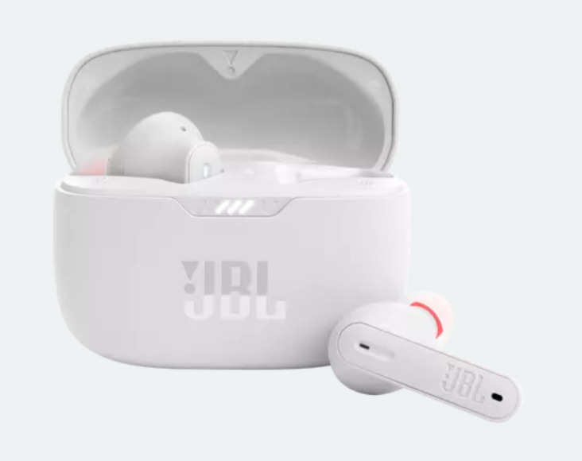  
  
D:\Web Development\Free Code Camp\FCC Web Dev Projects\001 Responsive Web Design Certification\017 Capstone Project-4-Product Landing Page\Images and Videos  
  
